

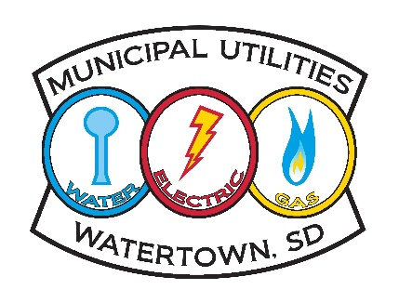

The Watertown Municipal Utilities Water Department is starting a hydrant and main flushing program this August. This program is to ensure fire hydrants are in good working order and to improve the performance of our distribution system by removing sediment that has built up over time.

This program will be performed through the City of Watertown from April through October each year, flushing a small section of the water system each month. Maps showing the current location of the system being flushed accompanied by tentative dates this will occur will be uploaded to our website by the first of each month at www.watertownmu.com.

We plan on performing our monthly flushing segments on the second Tuesday of each month, starting around 9:00am. Our goal is to complete each monthly segment by the end of the week, but it could stretch into the following week. If situations occur beyond our control and we can’t perform the days listed, we will continue the next day until the section of town is complete.

Reason for Flushing Program:
- To alleviate accumulation of mineral deposits within the water mains, thus reducing the incidence of discolored water.
- Preventative maintenance to make sure fire hydrants are in good working order

During the flushing, you may notice discolored or cloudy water and/or decreased water pressure. Depending on the section we are flushing, this could occur for 15 – 45 minutes in total.

Precautions to Take:
- Avoid, if possible, running water such as laundry, dishes and bathing.
- Turn off any automatic devices that bring water into your home such as ice makers.

What to do if you experience discolored or cloudy water:
- Avoid using any hot water until the following steps have been completed.
- Wait until the flushing is complete, then run COLD water through faucets for 10 – 15 minutes until the water clears up.
- Run one load of laundry without any clothes.

If you continue to experience discolored or cloudy water after flushing, please contact WMU at 605-882-6233.

Thank you for your patience and cooperation as we strive to improve the water quality for our customers.

